Administrator Guide
jWebSocket
Representation of data in real time through graphics using jWebsocket framework.
1.0

Versioning Control
Date | Version | Description | Author
20/02/2012 | 1.0 | Preparing the document. | Merly López Barroso

- Process application download
To install this application it is necessary to download jWebSocket client and server packages. The application is available for download at the following address:
http://jwebsocket.org/downloads .
Packages | Size
Charting Server | 162.5 Kb
Charting Client | 5.6 Mb

- Features of the installation environment
You need a server on which is mounted the database application. I do not understand this sentence. Do you mean a web server is required?
- Installation process
The application can be installed in two different ways, according to the operating system you are working.
Linux: must have previously installed Apache and then to copy in / var / www / the client application. You must give permission to access it.
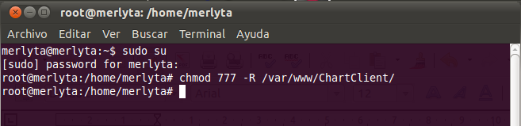

The application server may be located anywhere on the machine. Before running the client in the browser must be set to run the server on an IDE. <= Don’t understand that sentence. The server must run? But not necessarily from an IDE, what do you mean here?

Windows: previously you must install the Wamp application that creates the folder C: \ \ wamp \ www, in this url must be copied the client application. The server application can be stored in any location. Before running the client browser must be set to run the server on an IDE. <= see above, this sentence is not clear to me.

4. Configuration Options
4.1 Sigar libraries Locations.

For the full operation of this application it is necessary to copy some of the native libraries that have Sigar (System Information Gatherer And Reporter) library that allows us to get data from our computer.
Where do I get Sigar? Please add download locations (URLs).
Next the locations where should be copied the libraries will be described:

Archives | Linux | Solaris | Windows
32 bits | libsigar-x86-linux-1.6.4.so | libsigar-x86-solaris.so | sigar-x86-winnt.dll
64 bits | libsigar-amd64-linux.so | libsigar-amd64-solaris.so | sigar-amd64-winnt.dll
Directions | /usr/lib | /usr/lib | c:\program file\java\jdk\bin

This is because Sigar API is a multi-platform cross-language library and command-line can access the operating system tool.
You could add a bit more details about Sigar here, this is an important required tools for your Charting Demo.
The usage of MongoDB is missing completely. This is a requirement for the charting tool and thus needs to be mentioned here?
Please also describe the dependency or cooperation of the montoring plug-in. How are these interconnected? Here some more information

5. Putting into operation
The application is operated when the server jWebSocket is started. If you make ​​any changes to the server and it’s running, it stops and starts again so the changes are saved properly, how? where? Please give some more details here. After you open the client charting in browsers that support WebSocket. I don’t understand this sentence. What do you mean here?
5. Application Management
For administration of Charting Demo can be supported in the manual that corresponds to this application. This document should be the Administrator manual, so I expect all configuration options here! Please add the jWebSocket.xml and/or the spring config options here! This is essential in this document.
In the event of any problems during installation of the application, contact:
Alexander Schulze
Fon: +49 (0) 2407 902486
Fax: +49 (0) 2407 902487
Mail: a.schulze@jwebsocket.org

